Case Studies in Software Engineering

SE3070 | 2022

Critical Reflection Report

**Procurement Management System for Construction Industry**

Group ID : **SE3070_WD_31**

|  |  |
| --- | --- |
| Student ID | Name |
| IT20271350 | Punsala S.M.P. |
| IT20277086 | H.E.Meregngnage |
| IT20225056 | Benthara B.W.H.T. |
| IT20264666 | Fernando W.K. |

1. **Class Diagram**
   1. **Previous Diagram**

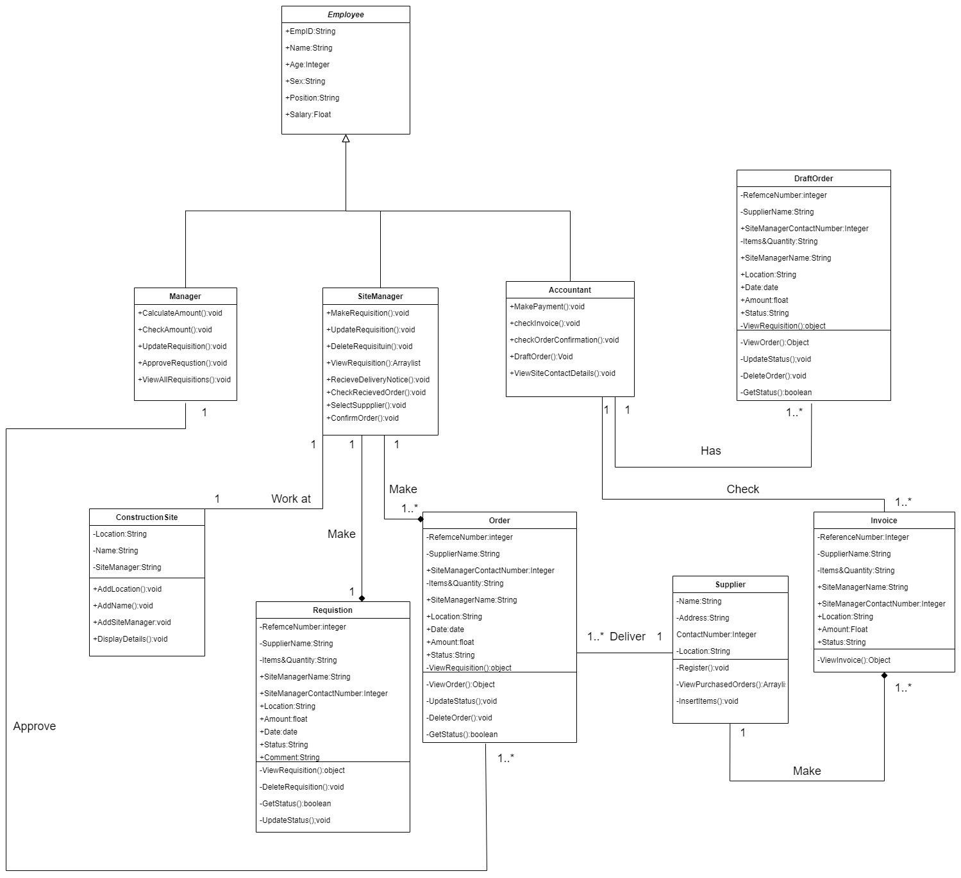

**Errors and Mistakes**:

1. Supplier and Order connected directly. There should be a delivery process between the supplier and order.
2. GetStatus() method is not important in Requisition class.
3. DraftOrder class is not important in the system.
4. Payment is not defined.

3

1

2

**05**

**Sequence Diagram for View Requisition and Approve**

**site manager.**

**06**

**.Wireframes**

**05.**

**Sequence**

**d**

**iagram**

**f**

**or**

**make a purchase**

**order**



1. Diagram, schematic

   Description automatically generated**New Diagram**

**Changes Made**:

* Delivery class is add between Supplier and Order classes.
* Remove GetStatus() method from the Requisition class.
* Remove DraftOrder class.
* Add Payment class and connect it with Accountant class.

1. **Sequence Diagrams**
2. **Sequence diagram for make a purchase request**

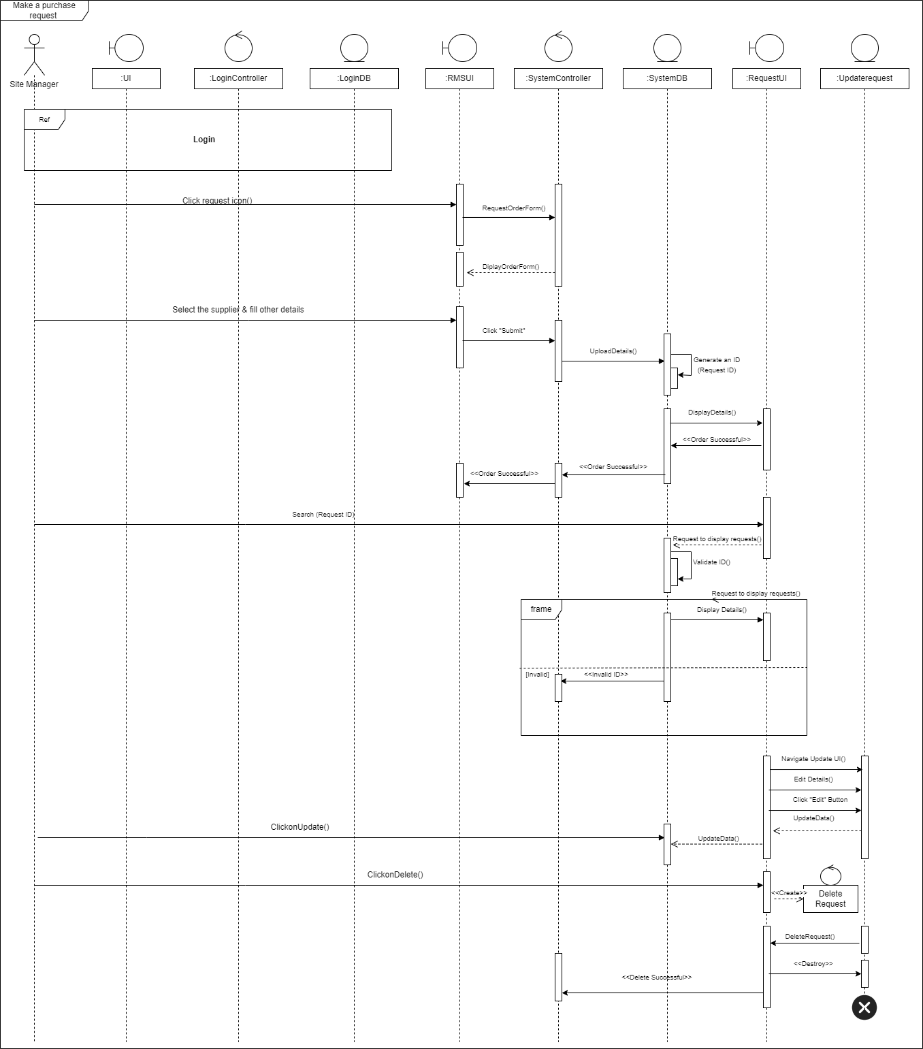

1. **Sequence diagram for approve a purchase request**
2. **Previous Diagram**

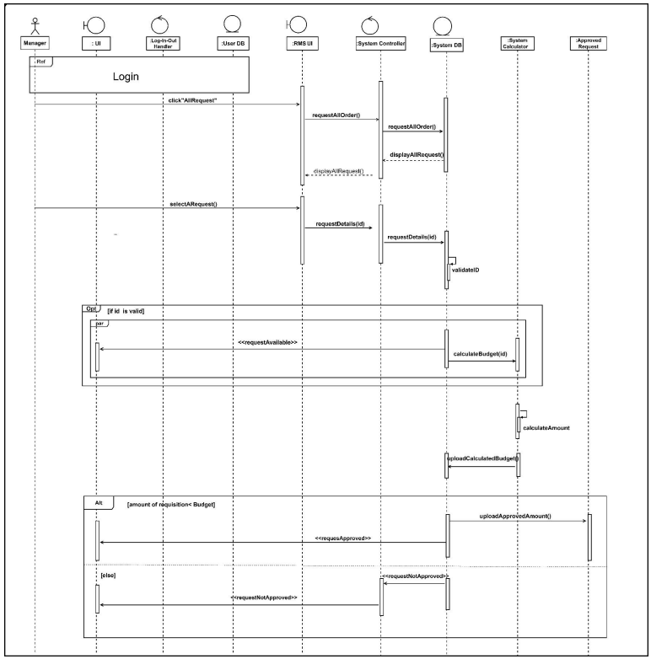

1. **New Diagram**

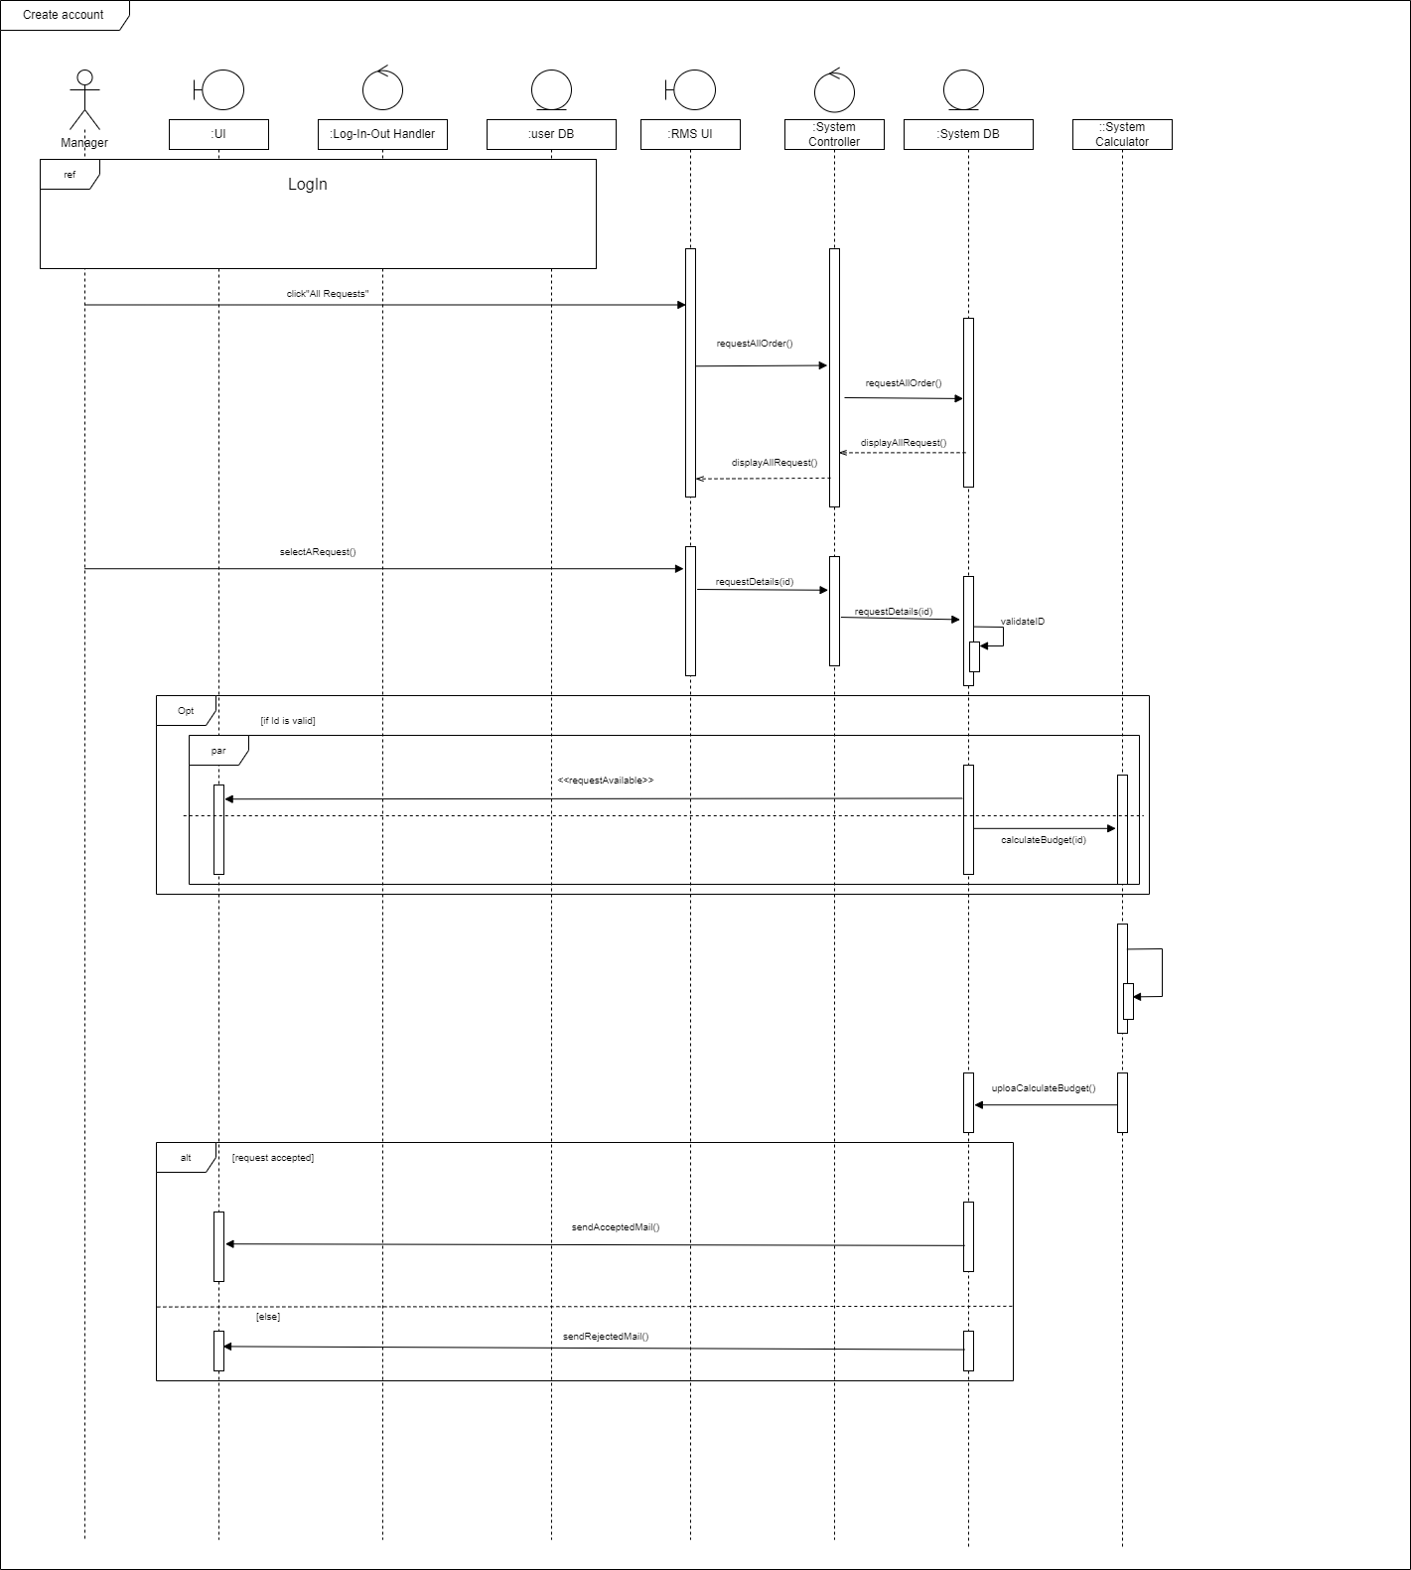

* In new system when manager accepted or rejected the order it will automatically send an email to the site manager.

1. **Sequence diagram for Payment**
2. **Previous Diagram**

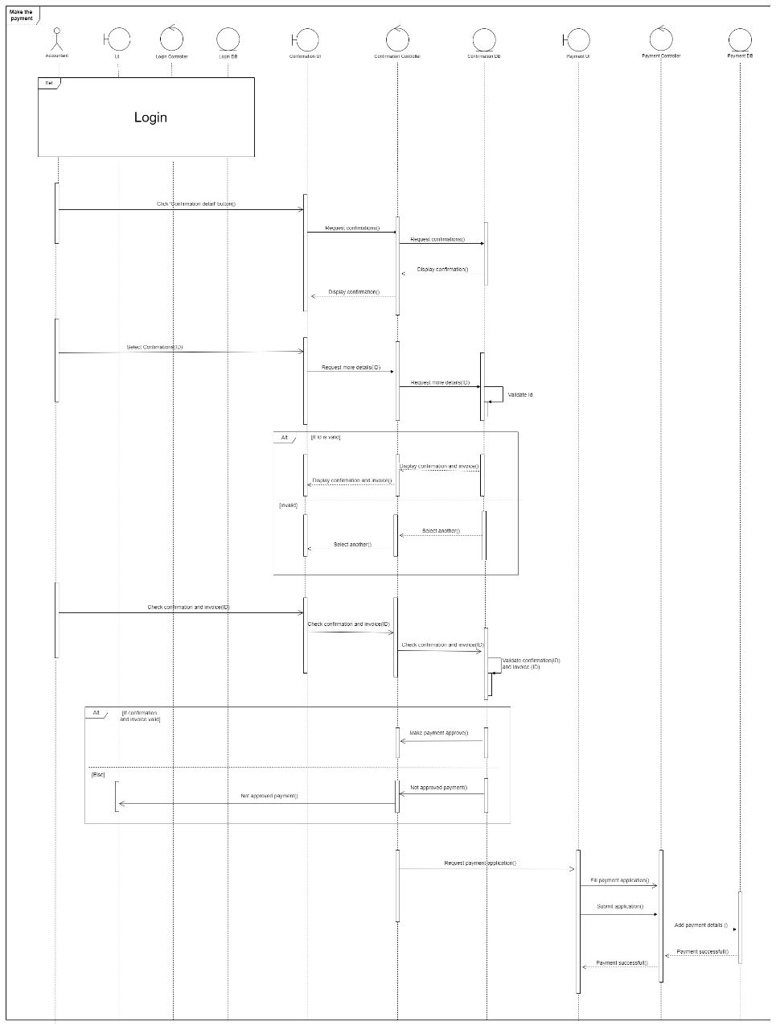

1. **New Diagram**

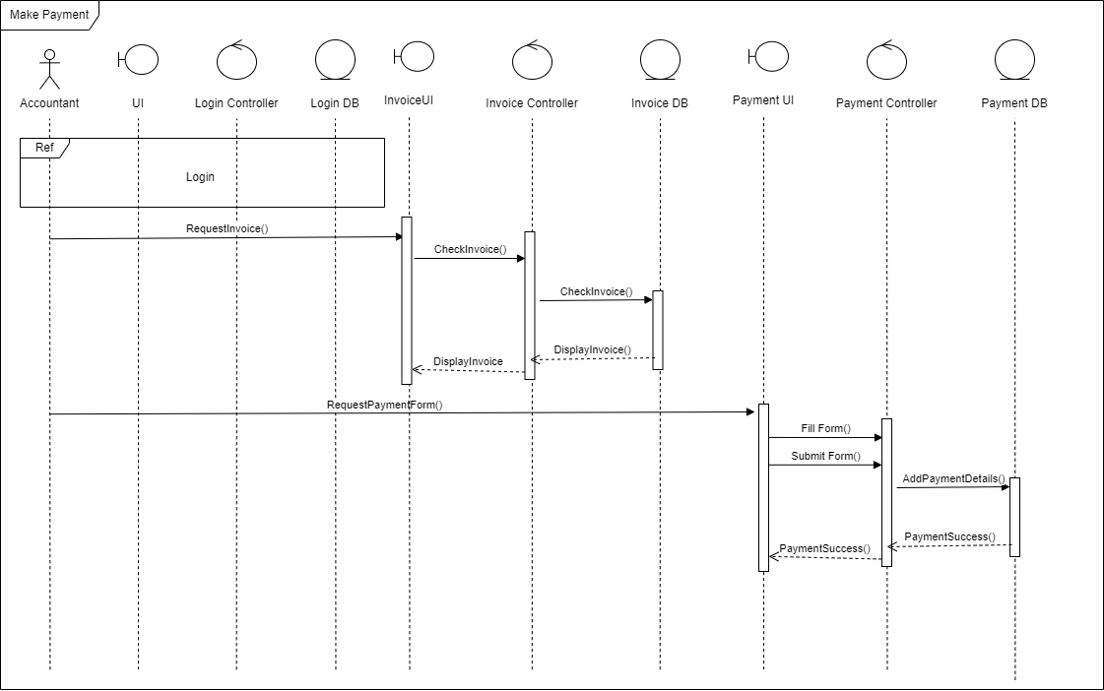

* In the original diagram accountant had the action to confirm an order, but since the manager must check and approve the order after checking it with the budget, having the accountant confirming again seemed unnecessary, therefore we have removed that action and left only the payment part after checking the invoice.

1. **Usage of UI Designs Provided**
2. 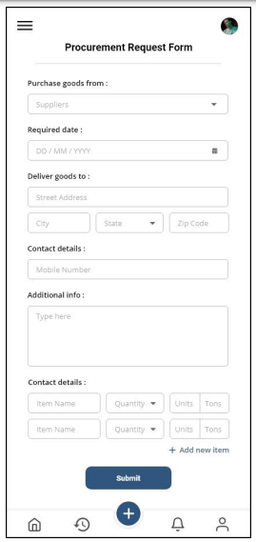**Previous Diagram**

* In new procurement request form, we have added some additional features.

1. **New Diagram**

